

# **LAB REPORT**

# **COMPUTER NETWORKS AND DATA COMMUNICATION**

**COURSE INTRUCTOR**

# **SIR MUBEEN AHMED KHAN**

# **GROUP MEMBER’S**

**MUHAMMAD HAMZA SHAMSI (2012392)**

**HUZAIFA ALI KHAN (2012385)**

**SAMRAH DURRANI (2012405)**

**JAVERIA SHEIKH (2012386)**

# **SECTION: 6G**

**79 CAMPUS**

**There are 8 PCs in Library of 79-building:**

* switch 1 = 8pcs
* Vlan 2
* 201.24.05.160
* 201.24.05.161
* 201.24.05.162
* 2^4-2
* 14IPS
* 201.24.05.160 – 201.24.05.175 /28
* 255.255.255.240

------------------------------------------------------------------------------------------------------

**There are seven PCs and two printers belong to HR department.**

* switch 1 = 7pcs 2 printer
* vlan 3
* 201.24.05.176
* 201.24.05.177
* 201.24.05.178
* 2^4-2
* 14IPS
* 201.24.05.176 - 201.24.05.191 /28
* 255.255.255.240

---------------------------------------------------------------------------------------------------

**There are four PCs and one printers belongs to Procurement department**.

* switch 1 = 4pcs 1 printer
* Vlan 4
* 201.24.05.192
* 201.24.05.193
* 201.24.05.194
* 2^4-2
* 14IPS
* 201.24.05.192 - 201.24.05.207 /28
* 255.255.255.240

--------------------------------------------------------------------------------------------------

**There are seven PCs and two printer belongs to ADMINISTRATION department**

* switch 1 = 7pcs 2 printer
* Vlan 5
* 201.24.05.208
* 201.24.05.209
* 201.24.05.210
* 2^4-2
* 14IPS
* 201.24.05.208 - 201.24.05.223 /28
* 255.255.255.240

------------------------------------------------------------------------------------------------------

**There are five PCs and two printers belongs to Finance department.**

* switch 1 = 5pcs 2 printer
* vlan 6
* 201.24.05.224
* 201.24.05.225
* 201.24.05.226
* 2^4-2
* 14IPS
* 201.24.05.224 - 201.24.05.239 /28
* 255.255.255.240

---------------------------------------------------------------------------------------------------

**There are three PCs and one printers belongs to EDC department**

* switch 1 = 3pcs 1 printer
* vlan 7
* 201.24.05.240
* 201.24.05.241
* 201.24.05.242
* 2^3-2
* 6IPS
* 201.24.05.240 - 201.24.05.247 /29
* 255.255.255.248

----------------------------------------------------------------------------------------------------

99 CAMPUS

**There are around 32 PCs belong to faculty and 6 printers.**

* switch 1 = 24pcs switch 2 = 8pcs 6 printer
* vlan 2
* 201.23.85.64
* 201.23.85.65
* 201.23.85.66
* 2^6-2
* 62IPS
* 201.23.85.64 - 201.23.85.127 /26
* 255.255.255.192

-------------------------------------------------------------------------------------------------

**There are 18 classrooms in 99-building, each class room has one PC**

* switch 1 = 18pcs
* vlan 3
* 201.23.85.128
* 201.23.85.129
* 201.23.85.130
* 2^5-2
* 30 IPS
* 201.23.85.128 - 201.23.85.159 /27
* 255.255.255.224

-------------------------------------------------------------------------------------------------

**There are 12 PCs and 4 printers belong to EXAMINATION department.**

* SWITCH 1 = 12PCS 4 PRINTER
* Vlan 4
* 201.23.85.160
* 201.23.85.161
* 201.23.85.162
* 2^5-2
* 30IPS
* 201.23.85.160 - 201.23.85.191 /27
* 255.255.255.224

------------------------------------------------------------------------------------------------

**There are six PCs and two printers belong to Academic department.**

* SWITCH 1 = 6PCS 2 PRINTER
* vlan 5
* 201.23.85.192
* 201.23.85.193
* 201.23.85.194
* 2^4-2
* 14IPS
* 201.23.85.192 - 201.23.85.207 /28
* 255.255.255.240

-------------------------------------------------------------------------------------------------

**There are four PCs and one printers belongs to IT department.**

* SWITCH 1 = 4PCS 1 PRINTER
* VLAN 6
* 201.23.85.208
* 201.23.85.209
* 201.23.85.210
* 2^4-2
* 14IPS
* 201.23.85.208 - 201.23.85.223 /28
* 255.255.255.240

-----------------------------------------------------------------------------------------------------

**There are two PCs belong to ADMINISTRATION department.**

* SWITCH 1 = 2pcs
* VLAN 7
* 201.23.85.224
* 201.23.85.225
* 201.23.85.226
* 2^3-2
* 6IPS
* 201.23.85.224 - 201.23.85.231 /29
* 255.255.255.248

**100 campus**

* **CS LAB 58 PCS, 2 PRINTER, 1 SERVER**
* SWITCH 1 = 24PCS
* SWITCH 2 = 24PCS
* SWITCH3 = 10PC, 2 PRINTER , 1 SERVER
* VLAN 2
* VLAN 3
* SWITCH 1 = 24PCS
* VLAN 2
* NETWORK 201.23.92.0
* GATEWAY 201.23.92.1
* MAIN SWITCH (VLAN 2) 201.23.92.2

2^6-2

* 62IPS
* 201.23.92.0 - 201.23.92.63 /26
* 255.255.255.192
* SWITCH 3 = 10PCS , 2 PRINTER , 1 SERVER
* VLAN 3
* NETWORK 201.23.92.64
* GATEWAY 201.23.92.65
* MAIN SWITCH (VLAN 3) 201.23.92.66
* 2^5-2
* 30IPS
* 201.23.92.64 - 201.23.92.95 /27
* 255.255.255.224

-------------------------------------------------------------------------------------------------------------------------------------------------

**100 CAMPUS**

**Lab-3 have 38 PCs, 2 Printer and 1 ftp server.**

* SWITCH 1 = 24PCS SWITCH 2 = 14PCS , 2 PRINTER , 1 server
* vlan 4

201.23.92.96

* 201.23.92.97
* 201.23.92.98
* 2^5-2
* 30IPS
* 201.23.92.96 - 201.23.92.127 /27
* 255.255.255.224
* SWITCH 2 = 14PCS , 2 PRINTER , 1 server
* vlan 5
* 201.23.92.128
* 201.23.92.129
* 201.23.92.130
* 2^5-2
* 30IPS
* 201.23.92.128 - 201.23.92.159 /27
* 255.255.255.224

-------------------------------------------------------------------------------------------

**100 CAMPUS**

**Lab-4 have 35 PCs and 2 Printer.**

* SWITCH 1 = 24PCS
* SWITCH 2 = 11PCS 2 PRINTER
* vlan 6
* vlan 7
* 201.23.92.160
* 201.23.92.161
* 201.23.92.162
* 2^5-2
* 30IPS
* 201.23.92.160 - 201.23.92.191 /27
* 255.255.255.224
* SWITCH 2 = 11PCS 2 PRINTER
* vlan 7
* 201.23.92.192
* 201.23.92.193
* 201.23.92.194
* 2^5-2
* 30IPS

201.23.92.192 - 201.23.92.223 /27

255.255.255.224

-------------------------------------------------------------------------------------------

**100 CAMPUS**

**There are 20 classrooms in 100-building, each class room has one PC.**

* SWITCH 1 = 20PCS
* vlan 8
* 201.23.92.224
* 201.23.92.225
* 201.23.92.226
* 2^5-2
* 30IPS
* 201.23.92.224 - 201.23.92.255 /27
* 255.255.255.224

**100 CAMPUS**

**Lab-5 have 35 PCs, 2 Printer and 1ftp server.**

* SWITCH 1 = 24PCS
* SWITCH 2 = 11PCS 2 PRINTER 1 SERVER
* vlan 9
* 201.23.86.0
* 201.23.86.1
* 201.23.86.2
* 2^6-2
* 62IPS
* 201.23.86.0 - 201.23.86.63 /26
* 255.255.255.192

-------------------------------------------------------------------------------------------

**100 CAMPUS**

**Smart Lab have 40 PCs and 1 Printer.**

* SWITCH 1 = 24PCS
* SWITCH 2 = 16PCS 1 PRINTER
* vlan 10
* 201.23.86.64
* 201.23.86.65
* 201.23.86.66
* 2^6-2
* 62IPS
* 201.23.86.64 - 201.23.86.127 /26
* 255.255.255.192

-----------------------------------------------------------------------------------------------------------------------------------------------

**100 CAMPUS**

**Lab-6 have 35 PCs only**

* SWITCH 1 = 24PCS
* SWITCH 2 = 11PCS
* vlan 11
* 201.23.86.128
* 201.23.86.129
* 201.23.86.130
* 2^6-2
* 62IPS
* 201.23.86.128 - 201.23.86.191 /26
* 255.255.255.192

-------------------------------------------------------------------------------------------------------------------------------------------------

**100 CAMPUS**

**There are around 25 PCs and 4 printers belong to faculty.**

* SWITCH 1 = 25PCS
* SWITCH 2 = 4 PRINTER
* vlan 12
* vlan 13
* SWITCH 1 = 25PCS
* vlan 12
* 201.23.86.192
* 201.23.86.193
* 201.23.86.194
* 2^5-2
* 30IPS
* 201.23.86.192 - 201.23.86.223 /27
* 255.255.255.224
* SWITCH 2 = 4 PRINTER
* vlan 13
* 201.23.86.224
* 201.23.86.225
* 201.23.86.226
* 2^3-2
* 6IPS
* 201.23.86.224 - 201.23.86.22.231 /29
* 255.255.255.248

-------------------------------------------------------------------------------------------------------------------------------------------------

**100 CAMPUS**

**There are four PCs belong to ADMINISTRATION department.**

* SWITCH 1 = 4 PCS
* vlan 14
* 201.23.86.232
* 201.23.86.233
* 201.23.86.234
* 2^3-2
* 6IPS
* 201.23.86.232 - 201.23.86.22.239 /29
* 255.255.255.248

---------------------------------------------------------------------------------------------------------------------------------

**100 CAMPUS**

**Gaming Lab have 9 PCs and 2 Printer.**

* vlan 15
* 201.23.85.0
* 201.23.85.1
* 201.23.85.2
* 2^4-2
* 14IPS
* 201.23.85.0 - 201.23.85.15 /28
* 255.255.255.240

--------------------------------------------------------------------------------------------------------------

**100 CAMPUS**

**There are 5 PCs and three printers belong to Academic department.**

* vlan 16
* 201.23.85.16
* 201.23.85.17
* 201.23.85.18
* 2^4-2
* 14IPS
* 201.23.85.16 - 201.23.85.31 /28
* 255.255.255.240

-------------------------------------------------------------------------------------------------------------------------------

**100 CAMPUS**

**There are ten PCs and two printers belongs to IT department.**

* vlan 17
* 201.23.85.32
* 201.23.85.33
* 201.23.85.34
* 2^4-2
* 14IPS
* 201.23.85.32 - 201.23.85.47 /28
* 255.255.255.240

**153 CAMPUS:**

**There are 8 PCs and three printers belong to Admission department.**

* SWITCH 1 = 8PCS 3 PRINTER
* VLAN 2
* 201.24.05.112
* 201.24.05.113
* 201.24.05.114
* 2^4-2
* 14IPS
* 201.24.05.112 - 201.24.05.127 /28
* 255.255.255.240

------------------------------------------------------------------------------------------

**There are 6 classrooms in 153-building, each class room has one PC.**

* SWITCH 1 = 6PCS
* vlan 3
* 201.24.05.128
* 201.24.05.129
* 201.24.05.130
* 2^4-2
* 14IPS
* 201.24.05.128 - 201.24.05.143 /28
* 255.255.255.240

**There are one PC and one printers belong to Academic department**

* switch 1 = 1 pc 1 printer
* vlan 4
* 201.24.05.144
* 201.24.05.145
* 201.24.05.146
* 2^3-2
* 6IPS
* 201.24.05.144 - 201.24.05.151 /29
* 255.255.255.248

-------------------------------------------------------------------------------------------------------------------------------------------------

**154 CAMPUS:**

**There are around 18 PCs and two printers belong to faculty.**

* SWITCH 1 = 18 PCS 2 PRINTER
* vlan 2
* 201.24.05.0
* 201.24.05.1
* 201.24.05.2
* 2^5-2
* 30IPS
* 201.23.05.0 - 201.23.05.31 /27
* 255.255.255.224

--------------------------------------------------------------------------------------------------

**There are 15 PCs and one printer belongs to Mechatronics Labs.**

* SWITCH 1 = 15 PCS 1 PRINTER
* vlan 3
* 201.24.05.32
* 201.24.05.33
* 201.24.05.34
* 2^5-2
* 30IPS
* 201.24.05.32 - 201.24.05.63 /27
* 255.255.255.224

**There are 8 classrooms in 154-building, each class room has one PC.**

* SWITCH 1 = 8 PC
* vlan 4
* 201.24.05.64
* 201.24.05.65
* 201.24.05.66
* 2^4-2
* 14IPS
* 201.24.05.64 - 201.24.05.79 /28
* 255.255.255.240

----------------------------------------------------------------------------------------------------

**There are one PC and one printers belong to Academic department.**

* SWITCH 1 = 1 PC 1 PRINTER
* vlan 5
* 201.24.05.80
* 201.24.05.81
* 201.24.05.82
* 2^3-2
* 6IPS
* 201.24.05.80 - 201.24.05.87 /29
* 255.255.255.248

**There are two PCs belong to ADMINISTRATION department.**

* SWITCH 1 = 2 PCS
* vlan 6
* 201.24.05.88
* 201.24.05.89
* 201.24.05.90
* 2^3-2
* 6IPS
* 201.24.05.88 - 201.24.05.95 /29
* 255.255.255.248

-------------------------------------------------------------------------------------------------------------------------------------------------

**SERVER DHCP**

* VLAN 7
* 20.0.0.0
* 20.0.0.1
* 20.0.0.2

**Media villa and Research villa:**

**There are 8 PCs and three printers belong to Faculty.**

* SWITCH 1 = 8PCS 3 PRINTER
* vlan 2
* 192.168.0.0
* 192.168.0.1
* 192.168.0.2
* 2^4-2
* 14IPS
* 192.168.0.0 - 192.168.0.15 /28
* 255.255.255.240

----------------------------------------------------------------------------------------------

**There are 3 classrooms and each class room has one PC.**

* SWITCH 1 = 3PCS
* vlan 3
* 192.168.0.16
* 192.168.0.17
* 192.168.0.18
* 2^3-2
* 6IPS
* 192.168.0.16 - 192.168.0.23 /29
* 255.255.255.248

-----------------------------------------------------------------------------------------------------------------------------------------------

**There are one PC and one printers belong to Academic department.**

* SWITCH 1 = 1PCS 1 printer
* vlan 4
* 192.168.0.24
* 192.168.0.25
* 192.168.0.26
* 2^3-2
* 6IPS
* 192.168.0.24 - 192.168.0.31 /29
* 255.255.255.248

----------------------------------------------------------------------------------------------------------------------------------------------

**Edge Router**

**CMS-EMAIL-WEBSERVER**

* 50.0.0.0
* 50.0.0.1
* 50.0.0.2
* 255.0.0.0

**ZABDESK**

* 60.0.0.0
* 60.0.0.1
* 60.0.0.2
* 255.0.0.0

-------------------------------------------------------------------------------------------------------------------------------------------------

**100 CAMPUS**

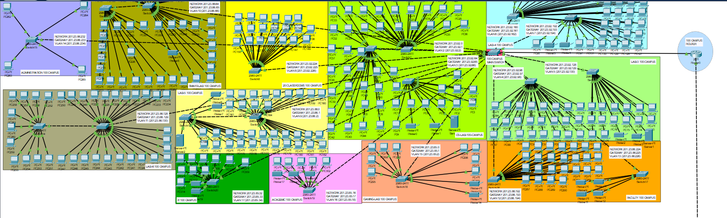

**99 CAMPUS**

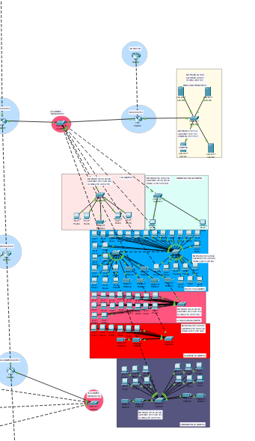

**154 CAMPUS**

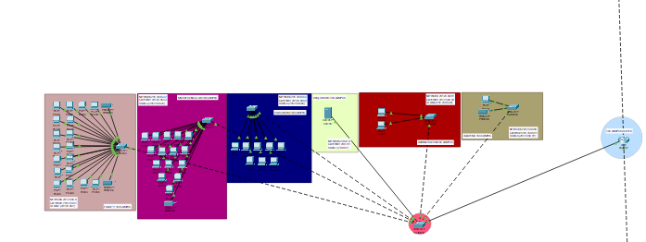

**153 CAMPUS**

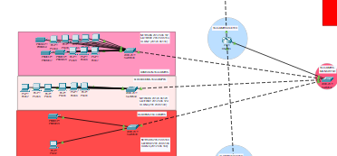

**79 CAMPUS**

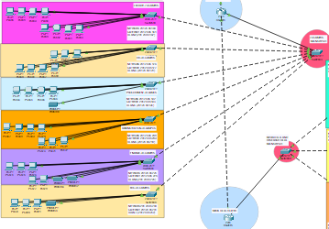

**MEDIA VILLA AND RESEARCH VILLA**

